**INTEGRATION OF AUTOMATION AND ROBOTIZATION INTO TECHNOLOGICAL PROCESSES OF AGRICULTURE: MODERN ACHIEVEMENTS AND DEVELOPMENT PROSPECTS**

***Shishkina Mariia Nikolaevna***

*e-mail:* [*mariyashishkina2610@gmail.com*](mailto:mariyashishkina2610@gmail.com)

***Scientific supervisor: Mavdasheva Rozalia Khaliyevna***

*e-mail:* [*rmavdasheva@mail.ru*](mailto:rmavdasheva@mail.ru)

Kazan State Agrarian University

**Abstract.** Agriculture is one of the key sectors of the world economy in which the integration of automation and robotization into technological processes is becoming increasingly important. This article reviews the current advances and development prospects in the integration of automation and robotization in agriculture. The advantages, challenges and potential development paths of this technological trend are discussed.

**Keywords:** Automation, robotization, agricultural technologies, production efficiency, innovations in agriculture, agricultural machinery

**Introduction.** Agriculture plays a key role in food scurity and sustainable development. However, modern challenges such as climate change, demographic changes and the need to improve production efficiency require the adoption of new technologies, including automation and robotization, to optimize production processes and increase yields.

**Current status and achievements.** There are already a number of automation and robotization technologies that are actively used in agriculture. This includes autonomous tractors and machines for seeding, harvesting and tillage, drones for monitoring and assessing crop health, and robots for sorting and packaging agricultural products. These technologies significantly improve production efficiency, lower labor costs and reduce environmental impact.

**New Holland**

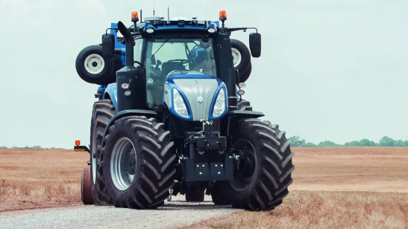

New Holland has unveiled the NHDrive autonomous tractor concept for a variety of field tasks. It can work with or without an operator, using access to a desktop computer for remote control. It is equipped with two RGB cameras and radar with LiDAR for effective monitoring and obstacle detection. The tractor offers high flexibility in operation and offers the ability to work with other machines to improve farmers' efficiency. It is envisaged that in the future the tractor cab can be completely removed to further optimize work processes and increase the level of automation.

**Semi-autonomous tractor**

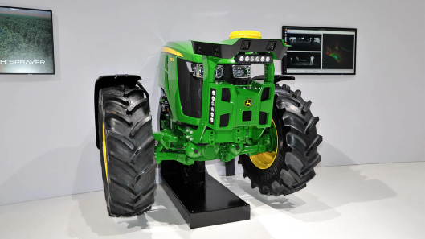

Semi-autonomous tractor. This tractor operates in semi-autonomous mode and has an integrated sprayer. Using the integrated camera, it is able to treat row crops, e.g. to apply crop protection products in orchards with fruit trees. The sprayer tank is filled automatically at the filling station, allowing the user to avoid contact with pesticides. This leads to cost savings and an increase in productivity of more than 30%.

**DJI Agras T16**

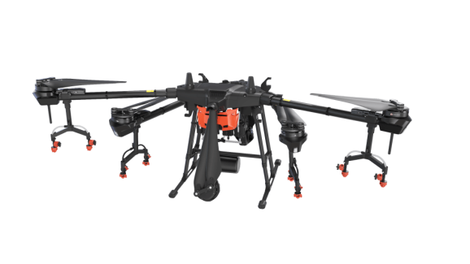

DJI Agras T16 is an advanced platform with improved modular design, higher payload and spraying. It is equipped with a DBF video locator for reliable orientation. Agras T16 takes into account different types of terrain and climatic conditions. This drone also has an artificial intelligence system to identify obstacles and fruit tree characteristics. It is the preferred choice for farmers and agroholdings in many countries, including Russia, due to its performance, reliability and adaptability.

**FANUC M-410iC/185**

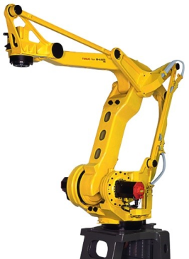

The FANUC M-410iC/185 robot is an efficient tool for palletizing and material handling operations. It has high speed and repeatability, capable of handling large grippers and heavy loads. The compact design and servo arm integration ensure easy maneuverability and efficient cable routing.

**Yaskawa Motoman MH24**  
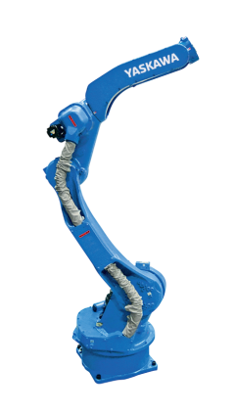

Industrial robot manipulator Yaskawa Motoman MH24 6-axis robot from Yaskawa is a multifunctional robot for different types of work. Load capacity of the model is 24 kg. The robot has a convenient design and compact size.

**ABB FlexPicker**

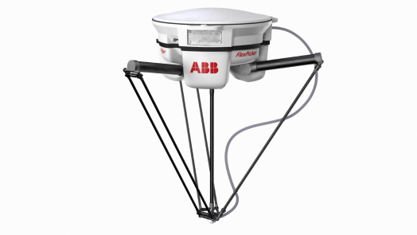

ABB's FlexPickerthat allows the robot to learn and adapt to a wide variety of items including cuboids, cylinders, pouches, blisters, and random shapes, as found in electronics, pharma, healthcare, cosmetics and other consumer product industries.

**Challenges and issues.** Despite significant advances, the integration of automation and robotization into agriculture also faces some challenges. One of the main challenges is the high cost of implementing new technologies, which may not be affordable for small farms.

Here, for example, is a graph of the growth in global spending on robotics:

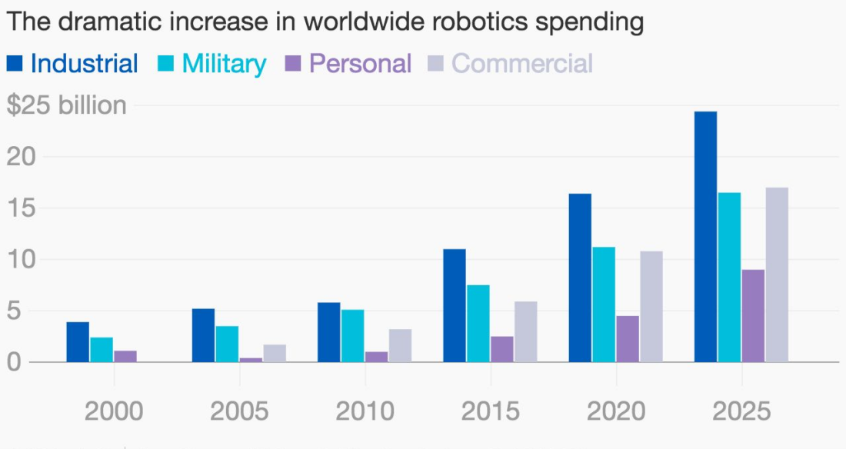

In addition, the need to support and maintain these technologies also requires specialized knowledge and skills, which can be a limiting factor for some agricultural businesses.

**Development prospects.** Despite the challenges, the development outlook for the integration of automation and robotization in agriculture is very encouraging. With the advancement in technology and increasing competition in the market for agricultural machinery manufacturers, the cost and availability of automated solutions for farmers of all sizes is expected to decrease. In addition, advancements in artificial intelligence and machine learning will enable more efficient and adaptive production management systems.

**Conclusion.** The integration of automation and robotization into agricultural processes represents an important technological trend that can significantly improve the efficiency and sustainability of this industry. Despite the challenges, the outlook for these technologies promises improved working conditions, reduced costs and increased production capacity. Further research and innovation in this area is key to ensuring sustainable agricultural development in the future

**References**